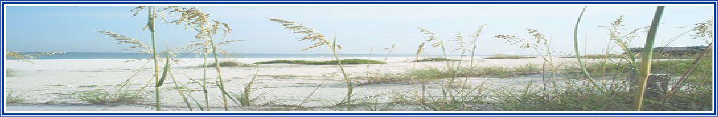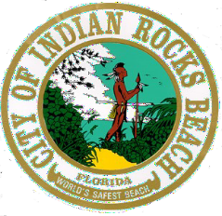
City of Indian Rocks Beach
1507 Bay Palm Boulevard, Indian Rocks Beach, Florida 33785
www.indian-rocks-beach.com

AGENDA- AMENDED
CITY OF INDIAN ROCKS BEACH
REGULAR CITY COMMISSION MEETING
TUESDAY, MARCH 12, 2024 @ 6:00 P.M.
CITY COMMISSION CHAMBERS
1507 BAY PALM BOULEVARD
INDIAN ROCKS BEACH, FLORIDA 33785

CALL TO ORDER
PLEDGE OF ALLEGIANCE
ROLL CALL

1. PRESENTATIONS.
A. REPORT OF Pinellas County Sheriff’s Office.
B. REPORT OF Pinellas Suncoast Fire & Rescue District.
C. PRESENTATION IRB Beach Community Food Pantry.

2. PUBLIC COMMENTS. [3-minute time limit per speaker.]
(Any member of the audience may come forward, give their name and address, and state any comment or concern that they may have regarding any matter over which the City Commission has control, EXCLUDING AGENDA ITEMS. All statements made to the City Commission shall be made to the City Commission as a whole, not directed to any individual City Commission Member, and no personal, impertinent, or slanderous remarks shall be permitted. No speaker shall be interrupted, and no debate shall occur between the speaker and the City Commission.)

3. REPORTS OF:
A. City Attorney.
B. City Manager.
C. City Commission.
[3-minute time limit per City Commission Member.]

4. ADDITIONS/DELETIONS.

5. CONSENT AGENDA:
A. APPROVAL OF the February 13, 2024 City Commission Meeting Minutes.
B. APPROVAL OF rescheduling June 11, 2024 Regular City Commission Meeting to June 18, 2024 at 6:00 p.m.
C. APPROVAL OF the process to appoint vacant Commission Seat.
D. APPROVAL OF Letter to Support for Strong Local Government Urban Fertilizer Ordinances.
E. AUTHORIZING the City Manager to award portions of Bid Number I.R.B.P.W.D. 2024-1 and enter into a contract with Harris-McBurney Company for the Outfalls 03 & 04 Projects in the amount of $1,670,084.69

6. PUBLIC HEARINGS:
A. BOA CASE NO. 2024-01- 314 6th Avenue.
CONSIDERING a variance request from Sec.110-131(1) f.2 (i) of the Code of Ordinance requesting an additional 3.34-foot incursion into the required 25 feet rear yard setback, resulting in a total setback of 21.66 feet for the enclosed stairway.

7. OTHER LEGISLATIVE MATTERS: None.

8. WORK SESSION: None.

9. OTHER BUSINESS: None.

10. ADJOURNMENT.

APPEALS: Any person who decides to appeal any decision made, with respect to any matter considered at such hearing, will need a record of the proceedings and, for such purposes, may need to ensure that a verbatim record of the proceedings is made, which record includes the testimony and evidence upon which the appeal is to be based, per s. 286.0105, F.S. Verbatim transcripts are not furnished by the City of Indian Rocks Beach, and should one be desired, arrangements should be made in advance by the interested party (i.e., Court Reporter).

In accordance with the Americans with Disability Act and s. 286.26, F.S., any person with a disability requiring reasonable accommodation to participate in this meeting should contact the City Clerk's Office with your request, telephone 727/595-2517 lkornijtschuk@irbcity.com, no later than FIVE (5) days before the proceeding for assistance.

POSTED: MARCH 11, 2024.

NEXT REGULAR CITY COMMISSION MEETING
TUESDAY, APRIL 9, 2024 @ 6:00 P.M.

Indian Rocks Beach Municipal Election.
The City of Indian Rocks Beach Municipal Election to fill (2) City Commission Seats will be held on Tuesday, March 19, 2024, in the Civic Auditorium, 1507 Bay Palm Boulevard, Indian Rocks Beach, Florida, from 7:00 a.m. until 7:00 p.m.

Swearing-in Ceremony and Reception for Mayor-Commissioner Kennedy.
The City of Indian Rocks Beach incoming City Commission will be sworn in during a public ceremony, on Thursday, March 28, 2024, at 6:00 p.m. The swearing-in ceremony will take place in the Civic Auditorium - 1507 Bay Palm Boulevard, Indian Rocks Beach, Florida.

Following the swearing-in ceremony, a reception will be held for Mayor-Commissioner Joanne “Cookie” Kennedy.

Please join us on March 28, 2024, as we honor Mayor-Commissioner Joanne “Cookie” Kennedy for years of dedicated service to the City of Indian Rocks Beach, as a city commissioner, board member, friend, environmentalist, and best of all, Mayor-Commissioner.

